**Updates required**

**Cricket Page:**

1. **Add cricket bat for customer selection**
2. **The page is not edited properly(picture on top of picture) please fix**

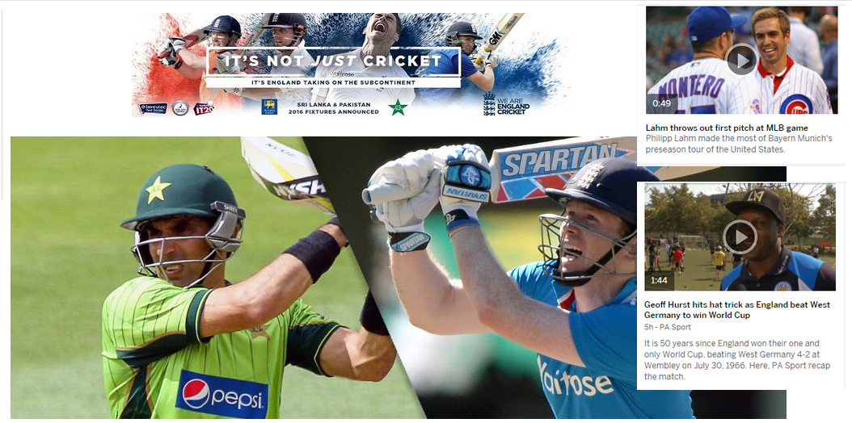

**Football page:**

1. **Move the main picture slightly to the right, the page alignment appears distorted because of it.**

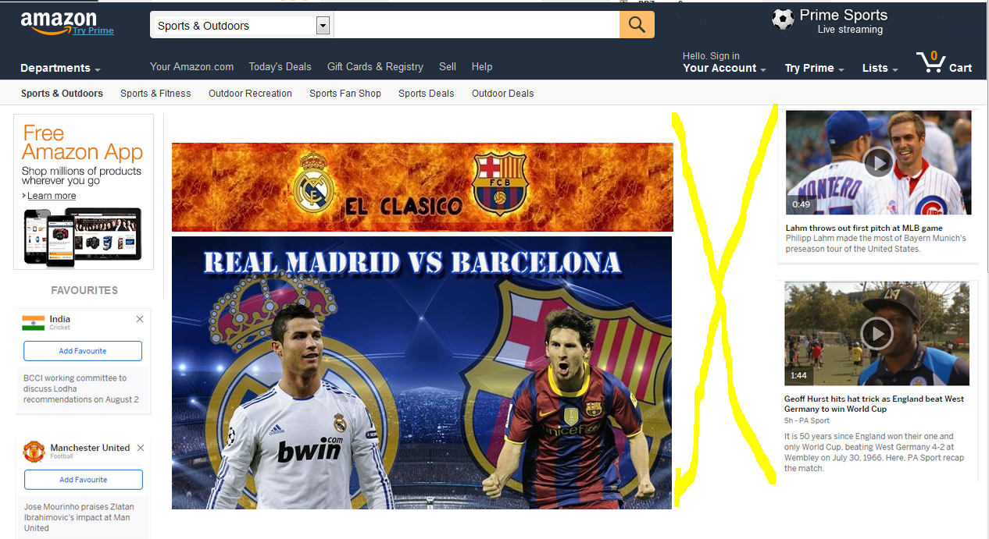

**Tennis Page**

1. **Change banner to the one I have provided **
2. **Change Federer t-shirt to the one I have provided**

**Rugby page**

1. **Main picture isn’t aligned**

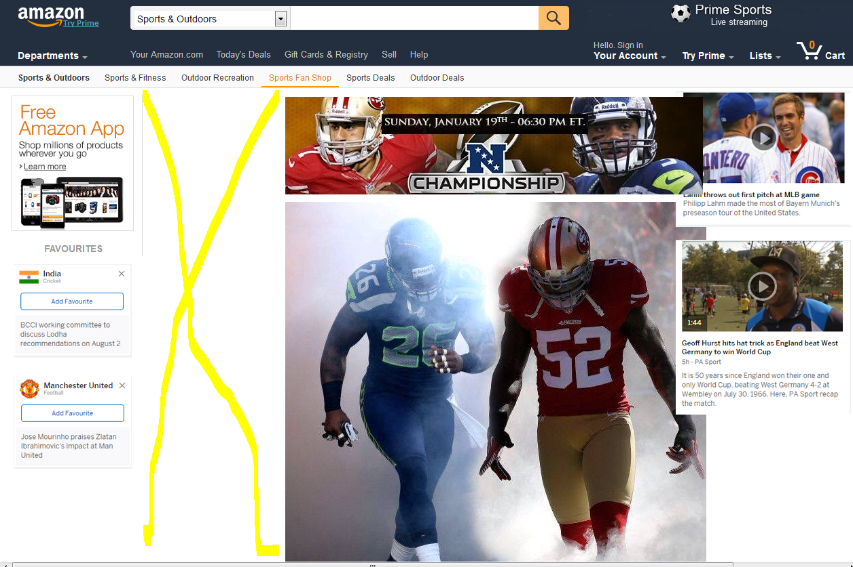

1. **I have provided the correct jersey and helmet pics. Please replace them.**

**Lastly to keep every page looking fresh can you please move around the scoreboard scores. For example instead of cricket being the first score for all the pages, have gold showing first in one page and football showing first in the second page.**

**Currently**



**Future:**

